AOCS Refer-a-Friend
Recruiter’s Toolkit

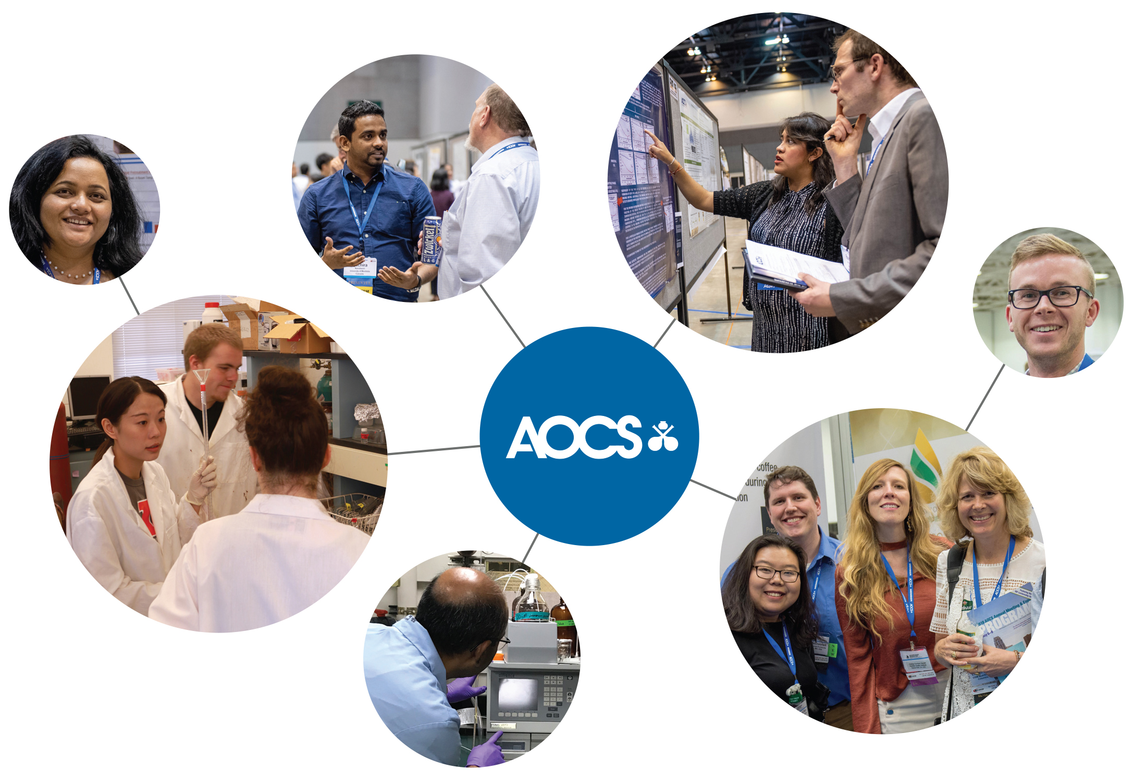

What’s inside:
- Recruiting tips
- Making the pitch
- Email copy template
- Social media copy template
Recruiting tips
Many people will be interested in learning about AOCS and how they can advance their career through networking and professional development. Here are some guidelines to help you effectively address the concerns of these potential members:

- Listen: While it can be discouraging to listen to objections to membership, you need to hear the entire story before you can change their perspective.

- Paraphrase: Repeat the objection in your own words, checking for understanding. “It sounds like you feel AOCS is only for a certain type of scientific professionals, do I have that correct?”

- Respond: When you respond, share your own positive AOCS experiences. “AOCS members are professionals working together to advance the science and technology of oils, fats, proteins, surfactants and related materials. By joining, you become part of a community that includes thousands of innovative professionals. You will be able to connect and collaborate with leaders throughout the industry and across the globe.”

- Anticipate specific objections, and how you might address them. Here are some suggestions:
  - I don’t see any benefit to joining, so why pay? “AOCS members have access to the latest scientific advancements, trends and hot topics through unlimited access to current and archived issues of AOCS journals, including Journal of the American Oil Chemists’ Society (JAOCS), Lipids and Journal of Surfactants and Detergents (JSD). They enjoy discounts on meeting registrations and AOCS publications, and can access exclusive member-only content through the AOCS Premium Content Library on inform|connect.”

  - Why do you care if I’m a member? “There is strength in numbers. As our membership grows, it will represent a more diverse set of specialties, backgrounds and locations which will enrich the entire membership experience.”

  - I’m not attending Annual Meeting this year. “AOCS membership provides resources, benefits and even opportunities to network beyond Annual Meeting. You can join Divisions tailored to your interest area and Sections designed to foster community near your location.”

  - AOCS only caters to [insert sector here] “One of the key strengths of AOCS is that members represent many scientific disciplines, all related to fats and oils. Membership is an opportunity to make connections and collaborate with leading researchers and innovators across industry, academia and government.”

Making the pitch
As our membership grows so does our ability to provide valuable networking opportunities and advance the industries we are a part of.

Help spread the word about the important role AOCS plays in the industry. Here are some tips to help you get started:

- Tell your story. Why did you join AOCS? What was the most compelling message about AOCS that made you want to join? If there was a person who influenced your decision to join, why did his/her opinion matter? What have you gained since becoming a member?

- Provide examples. A positive testimonial is one of the strongest tools. Describe how membership has helped you advance, either via tangible resources or the relationships you have built through AOCS.

- Focus on their needs. Discover their needs and connect them to how AOCS can serve and advance their unique goals. Be sure to name specific AOCS benefits/resources that will help them achieve each of their objectives.

- Close with a plan of action. Offer to email instructions for joining online, or to serve as a resource and answer any questions that may come to mind.

- Stay in contact. Touch base in a few weeks to see if they joined or have any questions. If they have not joined, this follow-up can serve as a gentle reminder.

Email copy template

Below is a sample email message you can use for inspiration when spreading the word to your contacts. Sharing your own AOCS story and how you have benefitted from membership can make a huge impact on recipients. Feel free to copy and paste or alter as you see fit!

Dear <<name>>

As a proud member of AOCS — the leading scientific Society serving professionals in fats, oils, proteins, surfactants and related materials — I wanted to share with you the benefit of joining our global community. [insert personal experience/story if applicable]

When you become an AOCS member, you gain exclusive access to emerging research, cutting-edge content, connections across the world, and opportunities for leadership experience and professional recognition. When you join now, not only will you access a wide array of unlimited, on-demand tools and resources, but we will both gain visibility with a mention on the AOCS blog.

The easiest way to join is online and you can learn more about the mission of AOCS and the various educational and networking opportunities made possible by membership here.

If you have any questions or concerns at all, I would be happy to discuss more details on the benefits of AOCS membership with you. Please don’t hesitate to reach out. And, of course, contact me when you decide to join so that I can be one of the first to welcome you to the Society!

Sincerely,

<<your name>>

Social media copy template
Active on Facebook, Twitter or LinkedIn? Use the sample social media copy below to easily spread the word to your networks. Plus – be sure to like AOCS on Facebook and follow us on Twitter so you can stay informed of the latest news and information:

Facebook: www.facebook.com/AOCSFan
Twitter: @aocs

Facebook and LinkedIn

Post 1: I encourage all of my peers working in the fats and oils industry to join AOCS. Members like me have unique opportunities to collaborate with leading researchers and innovators across industry, academia and government. Learn more to explore the ways AOCS can enrich your work. https://www.aocs.org/network-and-connect/membership/member-benefits

Post 2: Now is the time to join AOCS! AOCS provides professionals working in the science and technology of oils, fats, proteins, surfactants and related materials with networking, opportunities for leadership experience, and cutting-edge insights from publications. Become a part of the community this year. https://www.aocs.org/network-and-connect/membership/member-benefits

Post 3: When you join AOCS, you join an established support system that will advance your career as you advance the science and technology of lipids, oils, fats, surfactants, and related materials. Gain recognition in the AOCS blog when you join through me and discover your new professional home. Learn more. https://www.aocs.org/network-and-connect/membership/member-benefits

Twitter

Tweet 1: I consider AOCS my professional home and it can be yours too! Stay on top of the latest trends and collaborate with leading researchers and innovators across the world. Join AOCS today and gain global recognition in the AOCS blog! https://goo.gl/xQ6AAy

Tweet 2: Discover the many benefits of AOCS membership that I can personally say have shaped my career. Join me as a member of our global community today! https://goo.gl/xQ6AAy

Tweet 3: Discounts on meeting registrations, complimentary AOCS journals, savings on publications, and so much more—join me as a member of the global AOCS network and advance the science of fats, oils, proteins, surfactants and related materials: https://goo.gl/xQ6AAy

